**AI-Powered Customer Support for the Textile Industry**

**1. Real World Scenario & Limitations**

In the textile industry, particularly in B2B or wholesale operations, customers frequently inquire about product prices based on parameters like material, quality, and color. Traditionally, these queries are handled by a receptionist or sales staff during working hours.

**Limitations in the current system:**

* **Fixed Working Hours:** Support is only available between 9:00 AM to 6:00 PM.
* **Staff Availability:** Receptionist may be busy, on leave, or unavailable during high query volumes.
* **Language Barriers:** Customers from diverse regions may not speak the same language as the receptionist.
* **Delayed Responses:** Human error or workload can lead to slow replies, impacting customer satisfaction.

These bottlenecks affect customer experience and potentially result in lost opportunities.

**2. Reason to Implement AI-Based Product**

To overcome the limitations of manual support, we built an **AI-powered WhatsApp-based assistant** capable of understanding natural language queries and providing accurate responses instantly.

**Why we built this system:**

* **24x7 Availability:** Always active, no holidays.
* **Multilingual Understanding:** Can interpret queries in multiple languages.
* **Fast Response Time:** Instant replies, even during high demand.
* **Consistent Accuracy:** No human error in understanding or replying.
* **Customer Engagement:** Enhanced interaction quality with smart understanding of customer needs.

**3. Technical Overview for Interested Audiences**

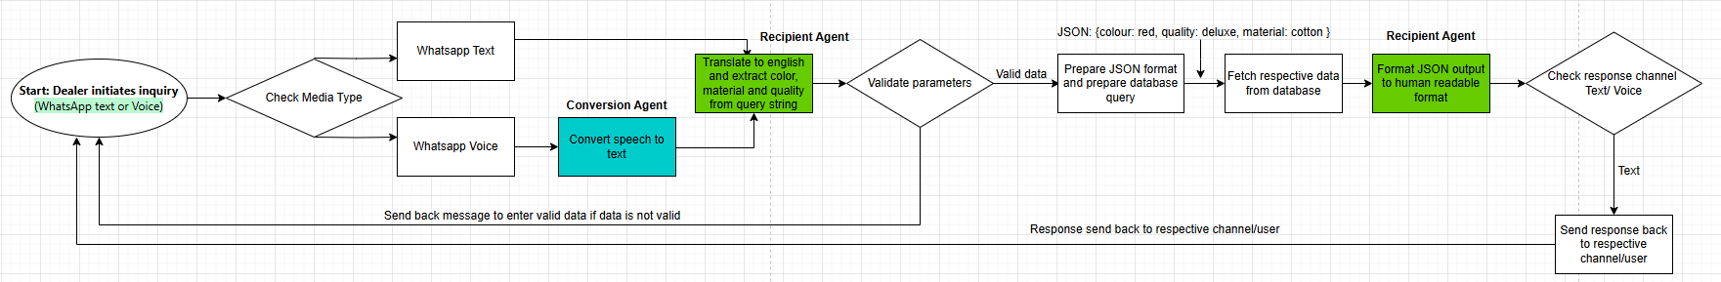

**Core Technologies Used:**

* **Python:** Chosen for its readability, speed of development, and large ecosystem.
* **AI Agents (LLM-based):**
  + Understand user messages
  + Translate languages if needed
  + Extract key data (material, color, quality)
  + Query pricing database
  + Format and send reply
* **WhatsApp Integration:** Using APIs like Twilio/Gupshup to send/receive messages
* **Structured Prompting:** To enhance agent understanding and ensure accurate query parsing

**Benefits of Python & AI Agents:**

* Rapid prototyping and flexible integration
* Easy to scale and maintain
* Leverage cutting-edge language models without deep AI knowledge

**4. Future Enhancements**

Our roadmap includes the following upgrades to make the assistant even more intelligent and versatile:

* **Voice-to-Text Integration:** Customers can send voice messages which will be transcribed and processed by the AI agent.
* **Voice-to-Voice Response:** AI can reply in audio format for easier communication.
* **Product Image Understanding:** AI can process product photos to understand customer intent.
* **CRM Integration:** Automatically log interactions and customer data to a CRM system.
* **Personalized Replies:** Based on previous history and preferences.
* **Marketing Purpose:** Based on previous queries we can encourage customer to buy related products.

**Conclusion:** This AI-powered system is not just a tool—it’s a 24x7 virtual employee that improves efficiency, boosts customer satisfaction, and helps businesses grow by leveraging the power of language models and automation.